**Github Project Activity**

**20K-0409 Mukand**

**Create Project**

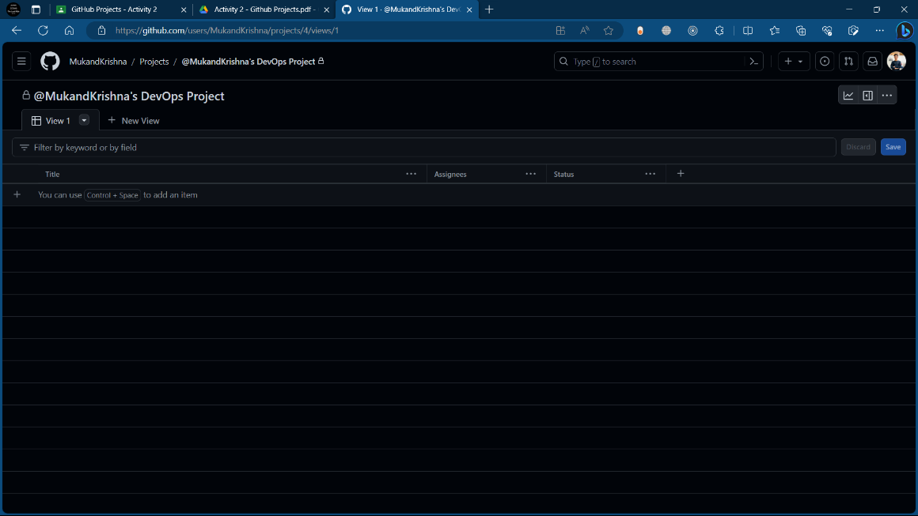

**Description:**

**Issue:**

**Iteration Field:**

**Customize Project views:**

